**NVIDIA Instant NeRF Installation**

1. **Install Visual Studio Community edition 2019**

<https://visualstudio.microsoft.com/vs/community>

1. **Installation of CUDA Toolkit**

To check cuda installation on your machine use below command:

If it is installed:

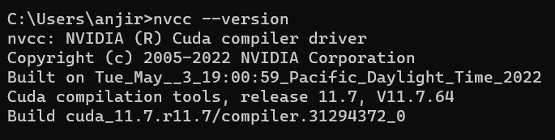

If it is not installed:

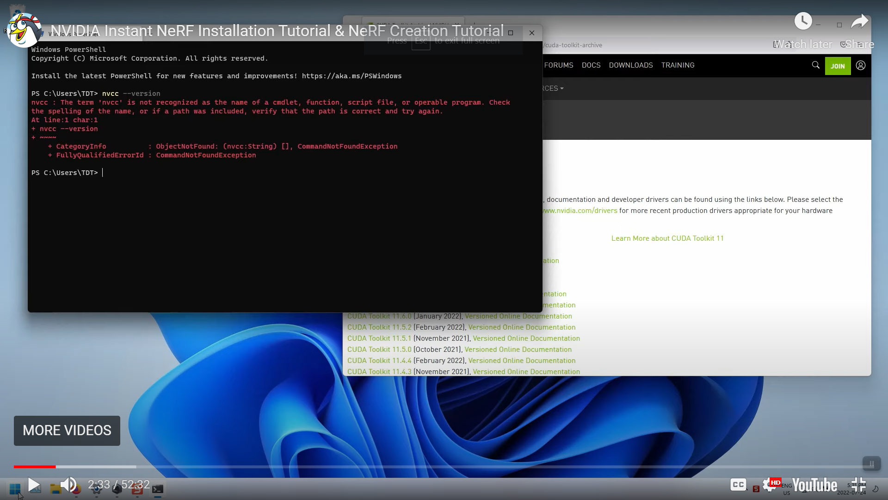

Download Cuda Tool Kit from this URL:

<https://developer.nvidia.com/cuda-toolkit-archive>

**Note:** If your GPU version is less than 3000 series then install Cuda Tool Kit version 10.2 otherwise install Cuda Tool Kit 11.x above.

1. **Download latest OpenEXR whl file using below URL**

<https://www.lfd.uci.edu/~gohlke/pythonlibs/#openexr>

1. **Download latest Anaconda version as per your OS Architecture.**

<https://www.anaconda.com/products/distribution>

1. Download latest NVIDIA OptiXTM version as per your OS Version & Architecture from below URL and install.

<https://developer.nvidia.com/rtx/ray-tracing/optix>

Normally OptiXTM SDK 7.3 above version works successfully.

Once Installation is done, set environment path variables as per below:

**System Explorer >> Edit the System Environment Variables >> Environment Variables**

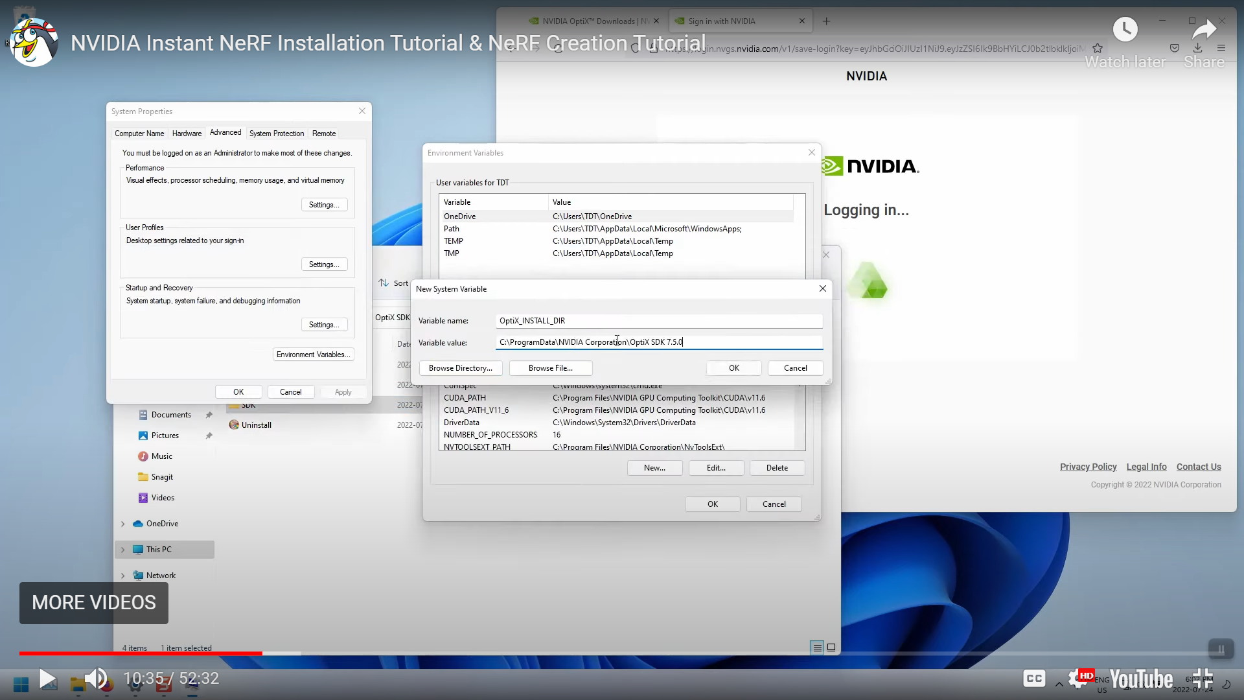

1. Check for correct Python Version.
2. Perform below step:

**Copy:** C:\Program Files\NVIDIA GPU Computing Toolkit\CUDA\v11.7\extras\visual_studio_integration\MSBuildExtensions

**To:** C:\Program Files (x86)\MSBuild\Microsoft.Cpp\v4.0\BuildCustomizations

or

C:\Program Files (x86)\Microsoft Visual Studio\2019\Community\MSBuild\Microsoft\VC\v160\BuildCustomizations

1. Create and change directory to install directory:

Ex: C:\ngp

1. If Git is not installed on your machine then download the required Git from below URL:

<https://git-scm.com/download/win>

Clone repository: git clone <https://github.com/NVlabs/instant-ngp>

Change dir: **cd instant-ngp**

1. Open Developer Command Prompt

Change directory to where the repository was cloned

Ex: D:\AI\NGP\instant-ngp

## Links to Required Tool

<https://github.com/colmap/colmap/releases/tag/3.7>

<https://www.lfd.uci.edu/~gohlke/pythonlibs/#openexr>